Growing shade   
Interactive Tool

User Guide

White Bar Art

The Council’s mission is to foster  
efficient and economic growth for   
a prosperous metropolitan region

**Metropolitan Council Members**

|  |  |
| --- | --- |
| Charlie Zelle Chair Judy Johnson District 1 Reva Chamblis District 2 Christopher Ferguson District 3 Deb Barber District 4 Molly Cummings District 5 Lynnea Atlas-Ingebretson District 6 Robert Lilligren District 7 Abdirahman Muse District 8 | Raymond Zeran District 9 Peter Lindstrom District 10 Susan Vento District 11 Francisco J. Gonzalez District 12 Chai Lee District 13 Kris Fredson District 14 Phillip Sterner District 15 Wendy Wulff District 16 |

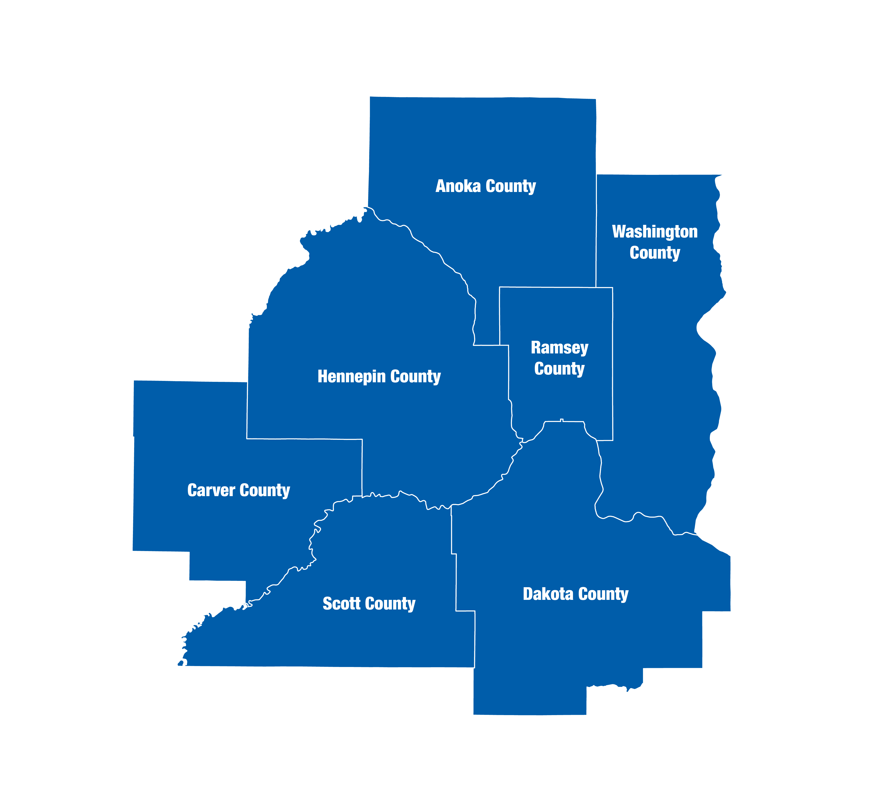  
The Metropolitan Council is the regional planning organization   
for the seven-county Twin Cities area. The Council operates the regional bus and rail system, collects and treats wastewater, coordinates regional water resources, plans and helps fund regional parks, and administers federal funds that provide housing opportunities for low- and moderate-income individuals and families. The 17-member Council board is appointed by and serves at the pleasure of the governor.

On request, this publication will be made available in alternative formats to people with disabilities. Call Metropolitan Council information at 651-602-1140 or TTY 651-291-0904.

# Introduction

## What the Growing Shade Interactive tool does

The Growing Shade project recognizes that trees provide critical ecosystem services and are important components of both natural and built environments. With a desire to create healthy places for people to live (mitigate heat islands and/or reduce home cooling costs, reduce localized flooding risk, improve mental health, etc.) and a resilient future (carbon sequestration, biodiversity, etc.), building or enhancing tree canopy cover is an actionable step.

This interactive provides stories and data to identify areas where an enhanced tree canopy could have a disproportionately positive benefit for people and environment. Stories provide a narrative to contextualize the importance of this work within our region. Users can customize data variables to reflect specific priorities towards identifying tree planting opportunities. Data is also provided towards helping stakeholders evaluate other considerations involved with tree plantings, such as cost-benefit analysis and species considerations.

## What the Growing Shade Interactive tool cannot do

Users can create valuable, data-driven analyses through this tool. Our experience and research tells us that data cannot substitute for engagement with prioritized stakeholders to understand community-specific concerns or opportunities. The on-the-ground knowledge of residents and the expertise of practitioners are valuable sources of information necessary to enhance and refine the shared understanding of this data.

# User Interface – ALL COMING LATER!!!

## “Home” tab

On the home page, find a general overview about what this tool does, and ways in which you might find this tool useful. To begin using the tool, notice the tabs on the top of the screen. This document goes through each tab in detail.

Click the tabs on top of the screen to begin using the tool

## “Explore Census Data” tab

This tab allows users to explore Census data in detail, but does not provide an interpretation.

To customize the map on the left of the screen, select the geography, topic, and subtopic which should be mapped. Click on any area to see more information. Please note that a “full screen” option can be enabled for the map.

Data distribution information is shown within the plot on the right of the screen. This plot shows how trends have changed across years. Clicking on an area within the map will generate trend lines and text about the selected area. Information to help you understand the plot is provided.

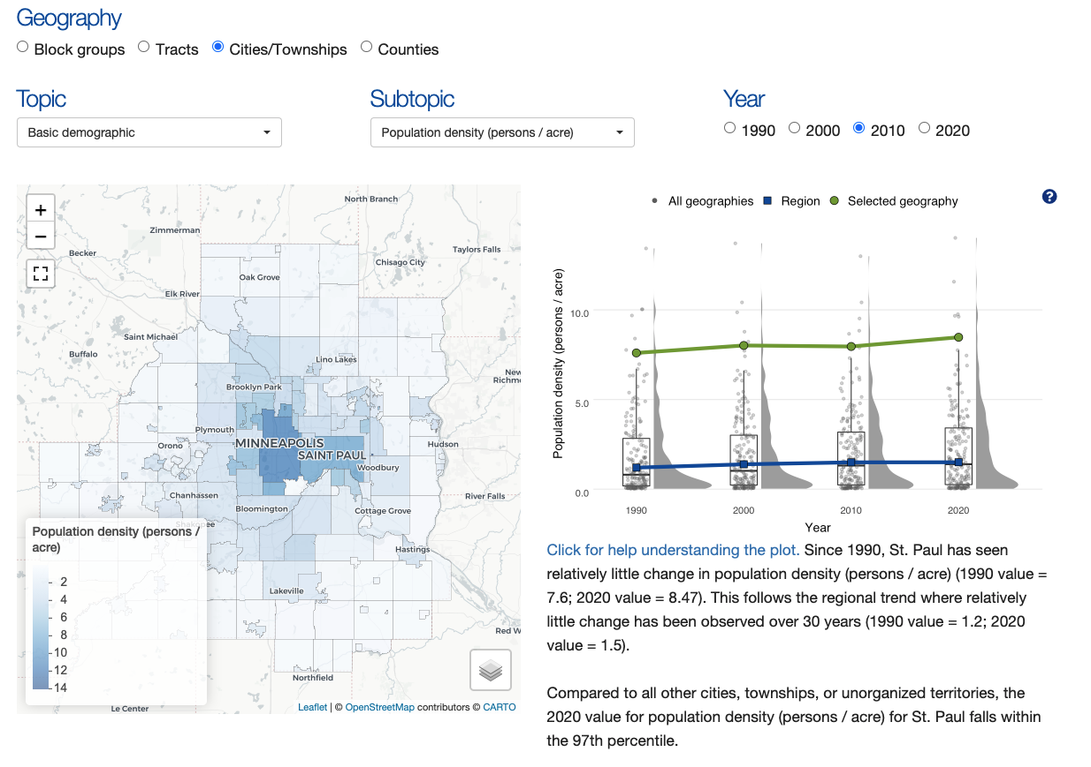

Enter full screen

Pick a geographic level

Information about understanding the plot

Pick a characteristic to analyze

Pick a year to map

Explore spatial patterns here

Explore variation across geographic areas here

## “Technical documentation” tab

This tab provides information about how the data was collected and processed.

­390 Robert Street North  
Saint Paul, MN 55101-1805

651.602.1000  
TTY 651.291.0904  
[public.info@metc.state.mn.us](mailto:public.info@metc.state.mn.us)  
metrocouncil.org

Follow us on:  
twitter.com/metcouncilnews  
facebook.com/MetropolitanCouncil  
youtube.com/MetropolitanCouncil

